CPSC 599/697 Biometric Technologies

Assignment 2 Requirements

Due: February 27th, Monday, 9:00 pm by e-mail to your TA

This is an individual assignment that intents to allow you to learn statistical method PCA, commonly sued for face recognition, and experiment with its MATLAB implementation.

It is worth 10% of your course mark.

Part I Objectives PCA THEORY
Part I of your assignment allows you to understand statistical data analysis behind PCA.
This part of assignment should be performed in two steps:
Step 1. Read tutorial titles: “principal_components_theory” that contains temporal simple step by step description of basic statistical concepts.
Perform exercises (all) listed on Page 5, Page 8, and Page 11 only.
Provide written answers to those exercises in Word document.

Part II Objectives PRACTICAL EXPERIMENTS
Part II of your assignment allows you to have a hands-on experience with PCA software.
Find the following webpage http://strata.uga.edu/software/. Chose “R tutorials” section and “Principal component analysis tutorial” to download the tutorial for PCA. Please also download the accompanying dataset.

Read and follow the instructions in the tutorial carefully. Copy and paste (or type) the R commands on the webpage to the R command window. Verify that you obtain similar results as shown in the tutorial. Provide screenshots of these results in your report.

Part III Objective Face Recognition using PCA

Implementation with explanation: http://www.face-rec.org/source-codes/

Download the following PDF:
Guide to face recognition with MATLAB/GNU Octave:
Author: Philipp Wagner

Detailed Explanation and Complete Source Code Examples
http://www.face-rec.org/source-codes/

Download Database (AT&T Face database):
http://www.cl.cam.ac.uk/Research/DTG/attarchive:pub/data/att_faces.zip

Install Octave IDE (GNU public license):
https://www.gnu.org/software/octave/

Goal: Run PCA software to generate Eigenfaces using 1, 10, 20, 50, 100, 150, 200, 250, and 300 principal components. Answer the question: what trend do you see as number increases from low tens to hundreds?

Your output should look something like that…
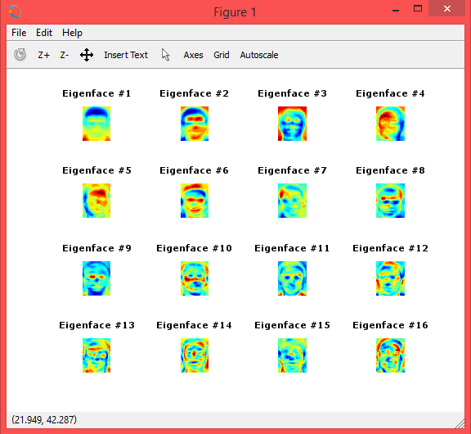

All three parts must be submitted in a single word or pdf file, where answers for part I and your own experimental results for part II and part III must be submitted as part of this file. This is an individual assignment.

